96 | Chest Routine (plain) | 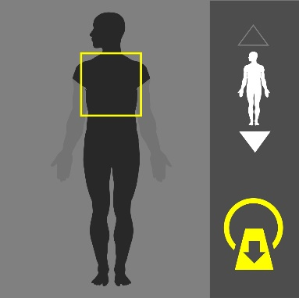
Purpose:
Trauma, pneumonia, pleural effusion, pneumothorax. Chest wall disease, post-operative assessment.

Instructions:
Use the image on the right as a guide. Cover the entire thorax.
Dual Scanograms |  | 120kVp | 50mA

Patient Preparation
- Train the patient on breath holding.

Scan Details
Mode | Beam | Pitch | kVp | mA | Sure Exp. 3D | FOV
Helical | 0.5 x 80 | HP Detail | 120 | R*** | Hi Quality | L

Procedure & Reconstruction Details
Phase | Coverage | Timing | Reconstructions (mm)
Plain | Above lung apices to below the diaphragm | - | Ax. 2x2 (mediastinum)(lung). 1x10 (HRCT)  Cor. 3x3 (lung)  Sag. 3x3 (lung)

Algorithm Details
Mediastinum | Kernel | FC08** | Filter | AIDR 3D STND | Boost | OFF | OSR | On
Lung |  | FC52 |  | OFF |  | OFF |  | On
HRCT |  | FC56 |  | OFF |  | OFF |  | On

Comments

96 | Chest Routine with Contrast | 
Purpose:
Lymphoma, metastatic disease (staging), pleural effusion, Respiratory distress of unknown cause , lung masses, mediastinal masses.

Instructions:
Use the image on the right as a guide. Cover the entire thorax.
Dual Scanograms |  | 120kVp | 50mA

Patient Preparation
- Train the patient on breath holding.
- Oral contrast might be required for studies focusing on the esophagus.
- Contrast media preparation is required.
- 20-24G cannula is required.

Scan Details
Mode | Beam | Pitch | kVp | mA | Sure Exp. 3D | FOV
Helical | 0.5 x 80 | HP Detail | 120 | R*** | Hi Quality | L

Procedure & Reconstruction Details
Phase | Coverage | Timing | Reconstructions (mm)
Plain | Above lung apices to below the diaphragm | - | Ax. 2x2 (mediastinum)(lung), 1x10 (HRCT)  Cor. 3x3 (lung)  Sag. 3x3 (lung)
 | Volume: 100cc Rate: 2.5-3.0cc/s** Delay: 45s
Chest +C | Above lung apices to below the diaphragm | 45s | Ax. 2x2 (mediastinum)  Cor. 3x3 (mediastinum)  Sag. 3x3 (mediastinum)

Algorithm Details
Mediastinum | Kernel | FC08 | Filter | AIDR 3D STND | Boost | OFF | OSR | On
Lung |  | FC52 |  | OFF |  | OFF |  | On
HRCT |  | FC56 |  | OFF |  | OFF |  | On

Comments
98 | High Resolution Chest (HRCT) | 
Purpose:
Evaluate interstitial lung disease, idiopathic pulmonary fibrosis, emphysema, and bronchiectasis, respiratory distress of unknown cause.
Instructions:
Use the image on the right as a guide. Cover the entire thorax.
Dual Scanograms |  | 120kVp | 50mA

Patient Preparation
- Train the patient on breath holding.
- Expiratory scan might be required in some cases. Discuss with radiologist, especially in cases if emphysema, lucent areas or mosaic pattern is picked up in the inspiratory scan.

Scan Details
Mode | Beam | Pitch | kVp | mA | Sure Exp. 3D | FOV
Helical | 0.5 x 80 | HP Detail | 120 | R*** | Hi Quality | L

Procedure & Reconstruction Details
Phase | Coverage | Timing | Reconstructions (mm)
Plain | Above lung apices to below the diaphragm | - | Ax. 2x2 (mediastinum), 1x10 (HRCT)  Cor. 1x10 (HRCT)  Sag. 1x10 (HRCT)

Algorithm Details
Mediastinum | Kernel | FC08 | Filter | AIDR 3D STND | Boost | OFF | OSR | On
HRCT |  | FC56 |  | OFF |  | OFF |  | On

Comments

102 | Chest CTA (Thoracic Aorta/Arch of Aorta) | 
Purpose:
To evaluated aortic dissection, aneurysms, penetrating atherosclerotic ulcers, traumatic injuries and inflammatory vsculitis.
Instructions:
Use the image on the right as a guide. Cover the entire thorax.
Dual Scanograms |  | 120kVp | 50mA

Patient Preparation
- Train the patient on breath holding.
- Contrast media preparation is required.
- 18G cannula is required.

Scan Details
Mode | Beam | Pitch | kVp | mA | Sure Exp. 3D | FOV
Helical | 0.5 x 80 | HP Detail | 120 | R*** | Hi Quality | L

Procedure & Reconstruction Details
Phase | Coverage | Timing | Reconstructions (mm)
Plain | Above lung apices to below the diaphragm | - | Ax. 2x2 (mediastinum)  Cor.  Sag.
 | Volume: 80-100cc Rate: 5.0cc/s Delay: SureStart
Chest CTA | Above lung apices to below the diaphragm | Sure  Start | Ax. 2x2 (CTA)  Cor. 2x2 (CTA) 3X2 (MIP)**  Sag. 2x2 (CTA) 3 X 2 (MIP)**

Algorithm Details
Mediastinum | Kernel | FC18 | Filter | AIDR 3D STND | Boost | OFF | OSR | On
Chest CTA |  | FC08 |  | AIDR 3D STND |  | OFF |  | On

Comments
- MIP coronal, MIP sagittal, and MIP obliques are required.
- dVR (VR/SSD) **

103 | Pulmonary Angio (CTA) | 
Purpose:
To evaluate pulmonary embolism (PE). It is emergency scan- triage patient for top priority.
Instructions:
Use the image on the right as a guide. Cover the entire thorax.
Dual Scanograms |  | 120kVp | 50mA

Patient Preparation
- Train the patient on breath holding.
- Contrast media preparation is required.
- 18G cannula is required (preferred on the Rt. side)

Scan Details
Mode | Beam | Pitch | kVp | mA | Sure Exp. 3D | FOV
Helical | 0.5 x 80 | HP Detail | 120 | R*** | Hi Quality | L

Procedure & Reconstruction Details
Phase | Coverage | Timing | Reconstructions (mm)
 | Volume: 50cc Rate: 5.0cc/s Delay: SureStart
Chest CTA | Above lung apices to below the diaphragm | Sure  Start | Ax. 1x1 (CTA), 3x3 (lung)  Cor. 2x2 (CTA)  Sag. 2x2 (CTA)

Algorithm Details
Chest CTA | Kernel | FC08 | Filter | AIDR 3D STND | Boost | OFF | OSR | On
Lung |  | FC52 |  | OFF |  | OFF |  | On

Comments
- MIP coronal, MIP sagittal, and MIP obliques are required.

104 | Thoracic Spine | 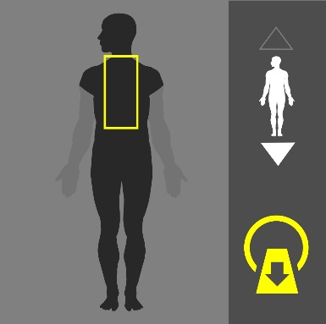
Purpose:
To evaluate thoracic spine diseases, fracture, bone lesions, and post-operative assessments.
Instructions:
Use the image on the right as a guide. Cover the thoracic spine.
Dual Scanograms |  | 120kVp | 50mA

Patient Preparation
No preparation is required

Scan Details
Mode | Beam | Pitch | kVp | mA | Sure Exp. 3D | FOV
W-Volume | 0.5 x 80 | - | 120 | 280 | OFF | M

Procedure & Reconstruction Details
Phase | Coverage | Timing | Reconstructions (mm)
T-Spine | C7 to L2 | - | Ax. 1x1 (Spine)(Soft)  Cor. 3x3 (Spine)  Sag. 3x3 (Spine)(Soft)

Algorithm Details
Spine | Kernel | FC35 | Filter | AIDR 3D STND | Boost | OFF | OSR | On
Soft |  | FC09 |  | AIDR 3D STND |  | OFF |  | On

Comments
- Use “SEMAR” version of the protocol when metallic implants are present.
- VR and 3D post-processing for all implants is required.

99 | Chest/Abdomen/Pelvis non-staging (-C/+C) | 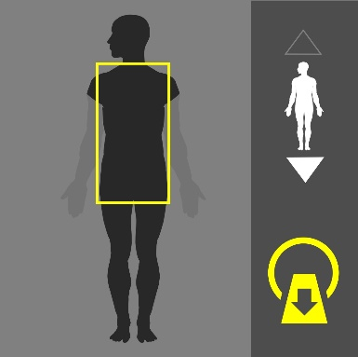
Purpose:
Abscess, infection spread and polytrauma.
Instructions:
Use the image on the right as a guide. Cover the entire torso from the apex of the lungs to the pubic symphysis.
Dual Scanograms |  | 120kVp | 50mA

Patient Preparation
- Contrast media preparation is required. 20G -24G cannula is required.
- Give 1.5L water over 90 minutes in equally spaced doses. Give 300-500 ml water on table stat.
- If it is acute emergency and there is not time- water contrast may be skipped- proceed directly to scanning.
- Discuss with radiologist, if he prefers positive contrast then use same dose regime but with oral iodine based contrast instead of water.

Scan Details
Mode | Beam | Pitch | kVp | mA | Sure Exp. 3D | FOV
Helical | 0.5 x 80 | HP Fast | 120 | R*** | Quality | L

Procedure & Reconstruction Details
Phase | Coverage | Timing | Reconstructions (mm)
Plain | Above lung apices to below ischium | - | Ax. 2x2 (abdomen)(lung)  Cor.  Sag.
 | Volume: 100-125cc Rate: 2.0-3.0cc/s Delay: 55s
Brain +C | Above lung apices to below ischium | 55s | Ax. 2x2 (abdomen)  Cor. 3x3 (abdomen)  Sag. 3x3 (abdomen)

Algorithm Details
Abdomen | Kernel | FC08 | Filter | AIDR 3D STND | Boost | OFF | OSR | On
Lung |  | FC52 |  | OFF |  | OFF |  | On

Comments

100 | Chest/Abdomen/Pelvis Staging (2 Phases) | 
Purpose:
Screening for metastasis, lymphoma and lung masses.
Instructions:
Use the image on the right as a guide. Cover the entire torso from the apex of the lungs to the pubic symphysis.
Dual Scanograms |  | 120kVp | 50mA

Patient Preparation
- Contrast media preparation is required. 18-20G cannula is required.
- Give 1.5L water over 90 minutes in equally spaced doses. Give 300-500 ml water on table stat.
- If it is acute emergency and there is not time- water contrast may be skipped- proceed directly to scanning. Discuss with radiologist, if he prefers positive contrast then use same dose regime but with oral iodine based contrast instead of water. Discuss need of contrast enema.

Scan Details
Mode | Beam | Pitch | kVp | mA | Sure Exp. 3D | FOV
Helical | 0.5 x 80 | HP Fast | 120 | R*** | Quality | L

Procedure & Reconstruction Details
Phase | Coverage | Timing | Reconstructions (mm)
Plain | Above lung apices to below ischium | - | Ax. 2x2 (abdomen)(lung)  Cor.  Sag.
 | Volume: 100-125cc Rate: 4.0-5.0cc/s Delay: SureStart
Late Arterial | Above lung apices to iliac crest | Sure  Start | Ax. 2x2 (abdomen)  Cor.  Sag.
Portal Venous | (above diaphragm to below ischium) | 60s | Ax. 2x2 (abdomen)  Cor. 3x3 (abdomen)  Sag. 3x3 (abdomen)

Algorithm Details
Abdomen | Kernel | FC08 | Filter | AIDR 3D STND | Boost | OFF | OSR | On
Lung |  | FC52 |  | OFF |  | OFF |  | On

Comments

